Cardiac Imaging Examples:

click image for movie (.avi)

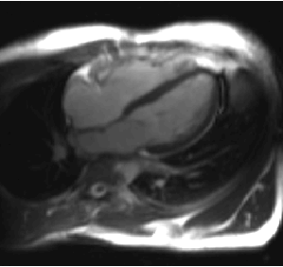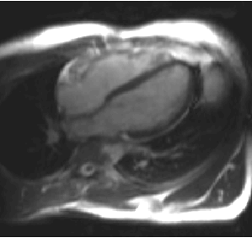
Rate 1 (5 fps) Rate 2 (10 fps)

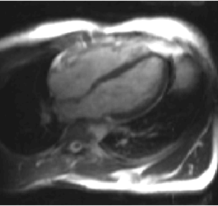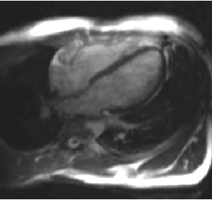
Rate 3 (15 fps) Rate 4 (20 fps)

Orientation: LAX
Sequence: real-time True-FISP
non-ECG triggered
normal free breathing
Matrix: 128x88
FOV: 300 x 282 mm²
Resolution: 2.3 x 3.2 mm²
Slice thickness: 8 mm
Readout flip angle: 55 deg
TR: 2.3 ms
Bandwidth: 1395 Hz/pixel
Acquisition duration: approx. 10 sec each
Acceleration: TSENSE Parallel Imaging method (rates 1 thru 4)
auto-calibrating TSENSE
without UNFOLD temporal filtering
Scanner: 1.5T Siemens Sonata
Coils: 8 element surface coil array (Nova Medical, Inc.)

